WEEK 3:

**Exercise 1: Configuring a Basic Spring Application**

**applicationContext.xml**

<?xml version="1.0" encoding="UTF-8"?>

<beans xmlns="http://www.springframework.org/schema/beans"

xmlns:xsi="http://www.w3.org/2001/XMLSchema-instance"

xsi:schemaLocation="

http://www.springframework.org/schema/beans

https://www.springframework.org/schema/beans/spring-beans.xsd">

<!-- Repository Bean -->

<bean id="bookRepository" class="com.library.repository.BookRepository" />

<!-- Service Bean -->

<bean id="bookService" class="com.library.service.BookService">

<property name="bookRepository" ref="bookRepository" />

</bean>

</beans>

</beans>

**BookRepository.java**

package com.library.repository;

public class BookRepository {

public void getBookList() {

System.***out***.println("Fetching book list from the repository...");

}

}

**BookService.java**

package com.library.service;

import com.library.repository.BookRepository;

public class BookService {

private BookRepository bookRepository;

public void setBookRepository(BookRepository bookRepository) {

this.bookRepository = bookRepository;

}

public void showBooks() {

System.***out***.println("Service: Displaying books...");

bookRepository.getBookList();

}

}

**LibraryApp.java**

package com.library;

import com.library.service.BookService;

import org.springframework.context.ApplicationContext;

import org.springframework.context.support.ClassPathXmlApplicationContext;

public class LibraryApp {

public static void main(String[] args) {

ApplicationContext context = new ClassPathXmlApplicationContext("applicationContext.xml");

BookService bookService = context.getBean("bookService", BookService.class);

bookService.showBooks();

}

}

Output:

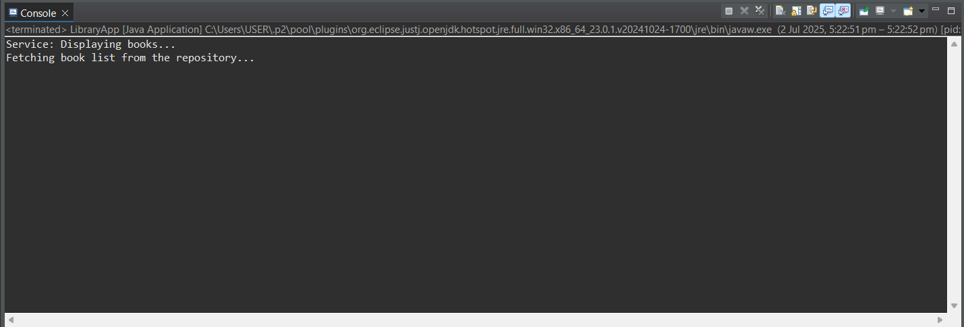

**Exercise 2: Implementing Dependency Injection**

Pom.xml

<project xmlns="http://maven.apache.org/POM/4.0.0" xmlns:xsi="http://www.w3.org/2001/XMLSchema-instance" xsi:schemaLocation="http://maven.apache.org/POM/4.0.0 https://maven.apache.org/xsd/maven-4.0.0.xsd">

<modelVersion>4.0.0</modelVersion>

<groupId>com.library</groupId>

<artifactId>LibraryManagement</artifactId>

<version>0.0.1-SNAPSHOT</version>

<dependencies>

<!-- Spring Core -->

<dependency>

<groupId>org.springframework</groupId>

<artifactId>spring-context</artifactId>

<version>5.3.34</version>

</dependency>

</dependencies>

</project>

**applicationContext.xml**

<?xml version="1.0" encoding="UTF-8"?>

<beans xmlns="http://www.springframework.org/schema/beans"

xmlns:xsi="http://www.w3.org/2001/XMLSchema-instance"

xsi:schemaLocation="

http://www.springframework.org/schema/beans

https://www.springframework.org/schema/beans/spring-beans.xsd">

<!-- Define the BookRepository bean -->

<bean id="bookRepository" class="com.library.repository.BookRepository" />

<!-- Define the BookService bean and inject BookRepository -->

<bean id="bookService" class="com.library.service.BookService">

<property name="bookRepository" ref="bookRepository" />

</bean>

</beans>

**BookService.java**

package com.library.service;

import com.library.repository.BookRepository;

public class BookService {

private BookRepository bookRepository;

// ✅ Setter method for DI

public void setBookRepository(BookRepository bookRepository) {

this.bookRepository = bookRepository;

}

public void showBooks() {

System.***out***.println("Service: Displaying books...");

bookRepository.getBookList();

}

}

**LibraryApp.java**

package com.library;

import com.library.service.BookService;

import org.springframework.context.ApplicationContext;

import org.springframework.context.support.ClassPathXmlApplicationContext;

public class LibraryApp {

public static void main(String[] args) {

// Load Spring context from XML

ApplicationContext context = new ClassPathXmlApplicationContext("applicationContext.xml");

// Get the BookService bean with injected BookRepository

BookService bookService = context.getBean("bookService", BookService.class);

// Call method to verify DI

bookService.showBooks();

}

}

**Output:**

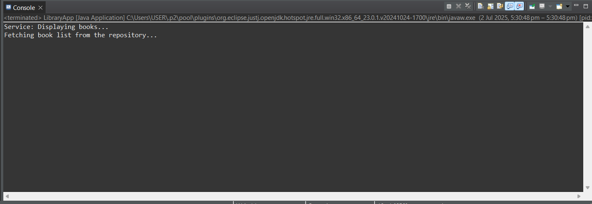

**Exercise 4: Creating and Configuring a Maven Project**

Pom.xml

<project xmlns="http://maven.apache.org/POM/4.0.0" xmlns:xsi="http://www.w3.org/2001/XMLSchema-instance" xsi:schemaLocation="http://maven.apache.org/POM/4.0.0 https://maven.apache.org/xsd/maven-4.0.0.xsd">

<modelVersion>4.0.0</modelVersion>

<groupId>com.library</groupId>

<artifactId>LibraryManagement</artifactId>

<version>0.0.1-SNAPSHOT</version>

<dependencies>

<!-- Spring Core -->

<dependency>

<groupId>org.springframework</groupId>

<artifactId>spring-context</artifactId>

<version>5.3.34</version>

</dependency>

<!-- Spring Context for core DI container -->

<dependency>

<groupId>org.springframework</groupId>

<artifactId>spring-context</artifactId>

<version>5.3.34</version>

</dependency>

<!-- Spring AOP for Aspect-Oriented Programming -->

<dependency>

<groupId>org.springframework</groupId>

<artifactId>spring-aop</artifactId>

<version>5.3.34</version>

</dependency>

<!-- Spring Web MVC for building web applications -->

<dependency>

<groupId>org.springframework</groupId>

<artifactId>spring-webmvc</artifactId>

<version>5.3.34</version>

</dependency>

</dependencies>

</project>